Sprint 2 Plan

Product Name : UpToDate

Team Name: UpToDaters

Release Name : UpToDate

Release Date : 3/19/18

Revision Number : 1

Revision Date : 2/5/18

Goal: Display reddit content on webpage and get familiar with django

Task Listing

* User Story 1: As a user, I want to be able to accept user input for the content they want to follow. (6 points)
  + Create a front-end on a python stack( 4 hours)
    - Create input fields for users (2 hours)
    - Create a layout for articles to be displayed (2 hours)
* User Story 2: As a user, I want to be able to store the articles in a database. (10 points)
  + Implement PRAW crawler in python <http://praw.readthedocs.io/> (3 hours)
  + Create tables in SQLite for user topics and create table for all the articles (2 hours)
  + Create a programmatic flow that iterates the user topic table and updates the articleTable (1 hour)
  + Extract data from the database(2 hours)

Team Roles

* Team Member Manav Sharma: Product Owner
* Team Member Tariq Anees: Scrum Master
* Team Member Andrew Boyadjiev: Developer
* Team Member Arthur Kung: Developer
* Team Member Tommy Tran: Developer
* Team Member Vanessa Tan: Developer

Initial Task Assignment

* Team Member Manav Sharma will work on user story #2 and his task is to implement the PRAW crawler
* Team Member Tariq Anees will work on user story #1 and his task is to create a layout for the articles to be displayed
* Team Member Andrew Boyadjiev will work on user story #1 and his task is to accept user input for the the content they want to follow
* Team Member Arthur Kung will work on user story #2 and his task is to add the top 5 results from a subreddit to the database
* Team Member Tommy Tran will work on user story #2 and his task is to create tables in SQLite for user topics and create a table for all the articles
* Team Member Vanessa Tan will work on user story #2 and her task is to extract data from the database

Initial Burn Up Chart

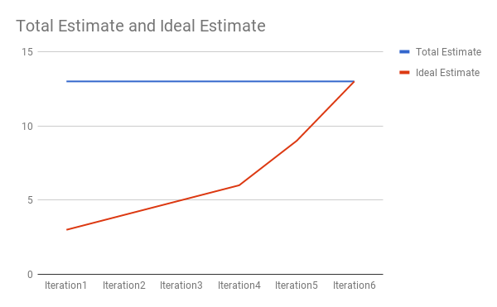

Initial Scrum Board

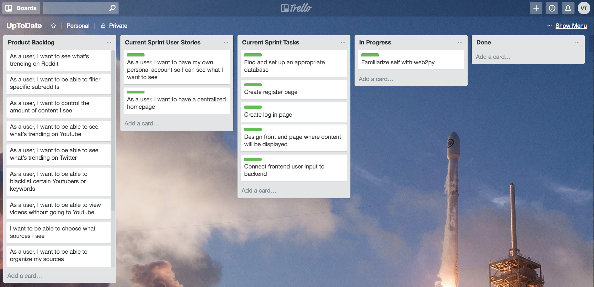

Scrum Times

* Monday at 11:30 am (TA visit)
* Wednesday at 9:00 am
* Friday at 9:00 am